**PARISH HOUSE & OFFICE**64 Mary Street  
Highgate WA 6003

**PHONE 9328 3433**

**OFFICE HOURS**

**Tues & Thurs 9.30am – 1pm**

**OFFICE EMAIL**  
[highgate@perthcatholic.org.au](mailto:highgate@perthcatholic.org.au)

**WEBSITE**

www.highgate.perthcatholic.org.au

**SAFEGUARDING OFFICER**

Helen O’Toole 0427 155 743

**Fr Mark Payton  
Parish Priest**

**Phone: 9328 3433**

**Rev Deacon Damian Gorian**

**Rev Deacon Aaron Peters**

**Parish Secretary Rosalia Carbone**

**LA FIACCOLETTA**

Nel seguire le attività Apostoliche, un viaggio molto delicato di Papa Francesco ha attratto la mia attenzione. Infatti si è recato proprio ieri, in visita alla spianata dove migliaia di affezionati si erano riuniti per accoglierlo. Nel 1948 ricordiamo un episodio molto serio che riguardava, da parte del Comunismo d'allora, l'uccisione di sette vescovi. Il Papa si è recato in Romania per beatificare questi Prelati e cercare l'amicizia di quel popolo in cui i cattolici sono circa il 7% della popolazione e che sono in crescita. Durante questo viaggio Apostolico ha visitato Blaj, detta città dei martiri, ricordata affezionatamente ‘la piccola Roma’ dove ha concluso la beatificazione. Ancora una volta la sensibilità Ecumenica del Papa ha avuto un successo positivo presso quei popoli nel intensificare le costruzioni di ospedali, case di cura per anziani e orfanotrofi distribuiti per tutta la nazione.

**SANTI DELLA SETTIMANA**

**Dom 9** Pentecoste

**Lun 10** Beata Vergine Maria, Madre della Chiesa

**Mar 11** S. Barnaba

**Gio 13** S. Antonio di Padova *Raffaele*

**MASS ROSTER**

|  |  |  |  |
| --- | --- | --- | --- |
| **Date/Time** | **Eucharistic Min** | **Commentator** | **Readers** |
| **8/6 6pm** | David Kerr  Nella Miranda | Ronan McGinniss | Mark Fernandez  Kharilyn Peermamode |
| **9/6 9am** | Brian Keane | Jacqui Matheson | Myles Brown  Leanne Davis |
| **10.30am** |  | Barbara Brunelli | Aurelia Elmendorp  Arduino Dal Busco  Connie Quattrini |
| **15/6 6pm** | David Kerr  Nella Miranda | Tara Peters | Malachy Doherty  Carl Mitchell |
| **16/6 9am** | Jacqui Matheson | Fred Komadina | Anita Pavic  Helen O’Toole |
| **10.30am** |  | Arduino Dal Busco | Connie Quattrini  Aurelia Elmendorp  Raffaele Basini |

**Heart and Voice**

**Sacred Heart Parish**

**Pentecost Sunday**

**9th June 2019 – C**

**MASSES**

Saturday Vigil: 6:00pm

Sun: 9:00am, 10:30am (Italian)

Tuesday - Friday: 7:00am

Sat and Public Holidays: 8:00am

**RECONCILIATION**

Sat: 5:00 - 5:30pm

or by appointment.

**MARRIAGES AND BAPTISMS**

By appointment.

**ADORATION OF THE**

**BLESSED SACRAMENT**  
After morning weekday Mass and after the Italian Mass on Sunday until 10.00pm.

C:\Users\highgate\Pictures\134.tif

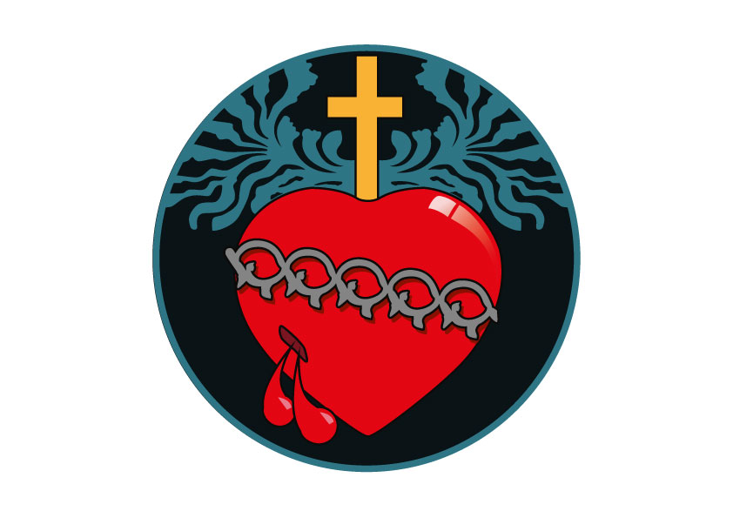



**Engineer Needed!**

If any parishioner is a qualified Structural Engineer could you please see Fr Mark after Mass or contact the Parish Office, as the parish requires some advice on a church maintenance issue. Thank you!



**Parish Celebration – Feast of the Sacred Heart of Jesus**

Following the 6pm Vigil Mass on **Saturday 29th June** there will be a shared dinner to celebrate the Sacred Heart of Jesus, our Parish feast day. All parishioners are invited to join us for this special social event. Dinner will start at 7pm in the Pastoral Centre Seminar Room. Everyone is asked to please bring a plate of food to share! If you can help with set up on the day, call Margaret on 0437 755 814. We look forward to enjoying a wonderful get-together with the whole parish community!



**Registrations Open for Australian Catholic Youth Festival – Perth**

Online registrations are officially open for the biggest Catholic youth festival to be held in Perth from 8-10 December 2019. Groups and individuals can register online at [**www.acyf.org.au**](https://catholicarchdioceseofperthcommunicationsoffice.cmail19.com/t/d-l-pijktuy-jltujrill-s/). All participants aged under 18 years must register as part of a group. As the largest gathering of the Catholic Church in Australia, the 2019 festival promises to be an exciting and powerful event for young people between Year 9 to 30 years old. The Festival aims to attract more than 5000 young people from every state and territory to deepen and celebrate their Catholic faith on local soil. The three-day event is an initiative of the Australian Catholic Bishops Conference hosted in partnership with the Archdiocese of Perth. The official theme of the Festival is ‘Listen to What the Spirit is Saying’. Experience live bands, dynamic speakers, workshops, forums and more! The Festival will be held at the Perth Convention and Exhibition Centre with the final Mass on the oval of Trinity College. For more information about the Festival go to [www.acyf.org.au](https://catholicarchdioceseofperthcommunicationsoffice.cmail19.com/t/d-l-pijktuy-jltujrill-g/).



**Baptism Prayers:** We pray for *Billy Rinaldi* who will be baptised this Sunday. We welcome him to our Parish Community.



**Pope’s Prayer Intention for June**

That priests, through the modesty and humility of their lives, commit

themselves actively to a solidarity with those who are most poor.

**Liturgical Calendar 9th – 16th June**

Sun 9th June: Pentecost Sunday – *Solemnity*

Mon 10th June: The Blessed Virgin Mary, Mother of the Church – *Memorial*

Tues 11th June: St Barnabas – *Memorial*

Thurs 13th June: St Anthony of Padua – *Memorial*



**Readings for 9th June: Pentecost Sunday**

Acts 2:1-11; Rom 8:8-17; Jn 14:15-16, 23-26

**Readings for 16th June: The Most Holy Trinity**

Prov 8:22-31; Rom 5:1-5; Jn 16:12-15



**Special Event – Dinner and Presentation this Saturday 8th June**

To coincide with the celebration of Pentecost, all parishioners and the broader community are invited to a special event. Commencing with dinner, the evening will include a unique presentation of “A Reflection on Giotto's Painted 'Life of Christ' in the Scrovegni Chapel, Padua". This will be presented by Vincent Moleta. As well as being a parishioner of Sacred Heart, Vincent is a former university scholar with special expertise in the arts, languages and history. Dinner is provided free of charge and will start at 7pm after the Vigil Mass in the Pastoral Centre Seminar Room with the presentation to follow.



**Encounter: Adoration + Praise + Worship**

On **Monday 10th June at 8pm** a special Adoration hour will be held in church with contemporary worship music and prayer. These nights are an opportunity to step aside from the everyday rush of life and connect with God. Everyone is welcome to attend! For more information please call Kylie on 0414 820 473 or email [perth@thecatholicguy.com](mailto:perth@thecatholicguy.com)



**Finance Talk at Masses Next Weekend**

Next weekend Sid Simonette, Chair of our Finance Committee will be giving a short talk at all Masses regarding the current financial position of our Parish and the benefits of the Planned Giving Program.



**Planned Giving Envelopes**

The new planned giving envelopes for July 2019 are available for collection from the church foyer. Please look for your name on the label. Thank you!